**Supplementary Materials D: G*Power Settings**

**Table 6**



*Figure D1.* Small effect (*gs* = 0.33), *t*-test.

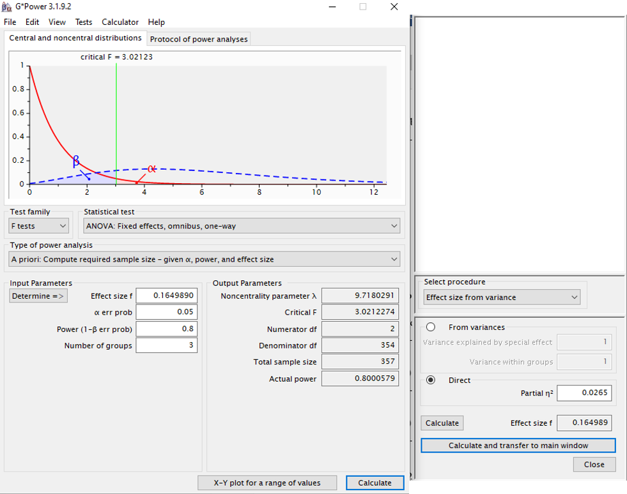

*Figure D2.* Small effect (*gs* = 0.33), ANOVA.

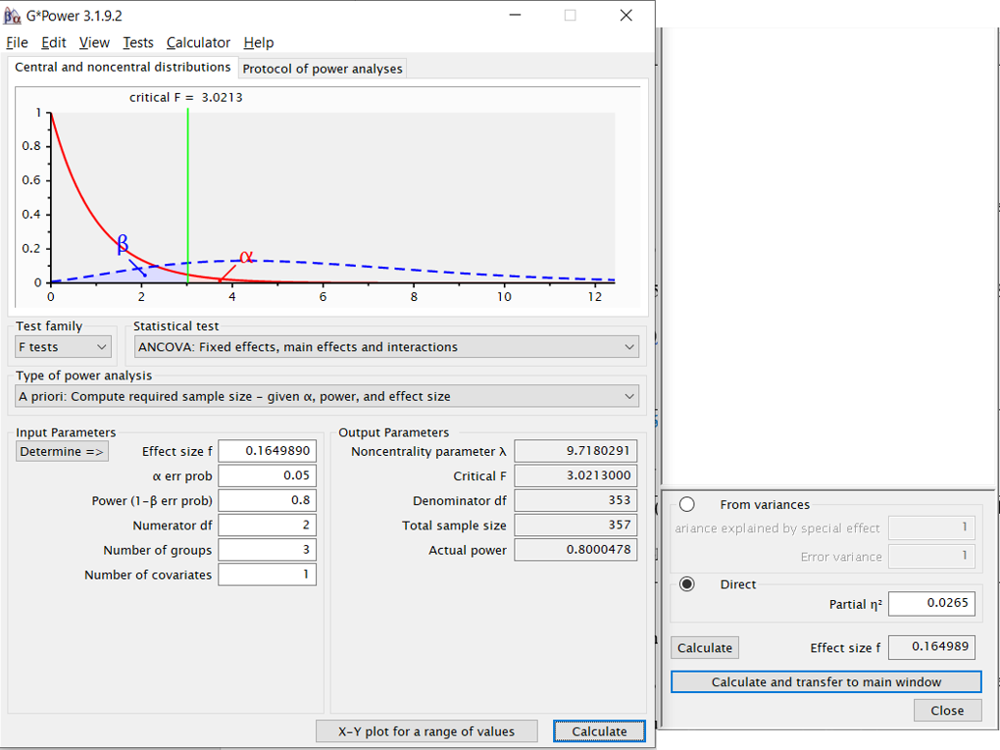

*Figure D3.* Small effect (*gs* = 0.33), ANCOVA.

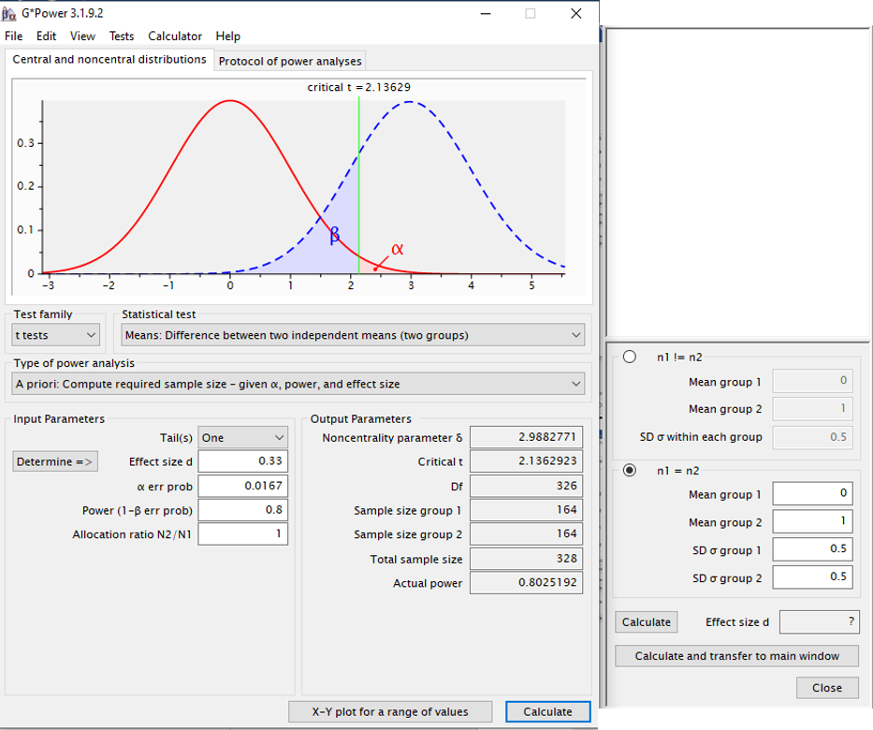

*Figure D4.* Small effect (*gs* = 0.33), ANOVA with post hoc tests.

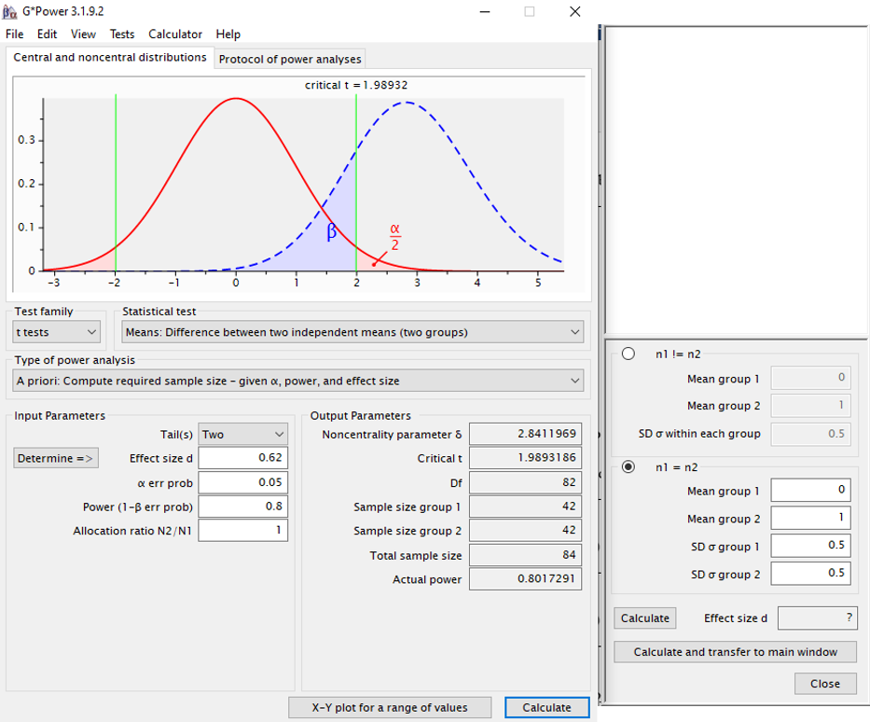

*Figure D5.* Medium effect (*gs* = 0.62), *t*-test.

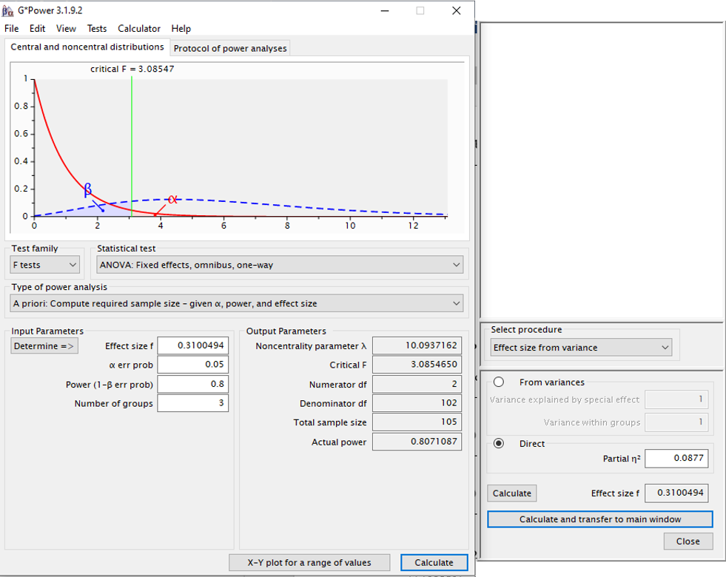

*Figure D6.* Medium effect (*gs* = 0.62), ANOVA.

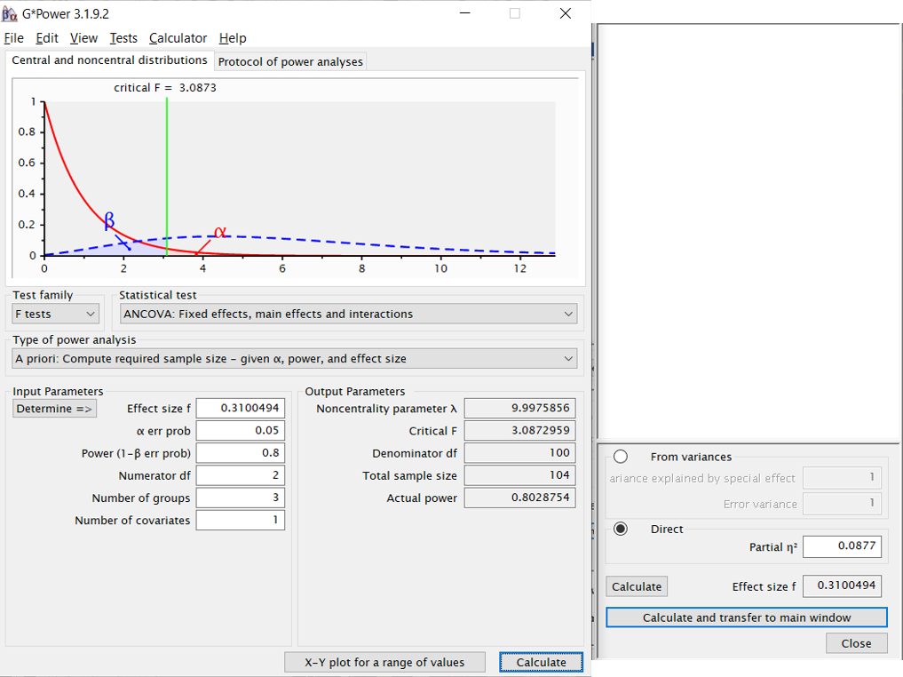

*Figure D7.* Medium effect (*gs* = 0.62), ANCOVA. G*power does not ensure 3 equal groups with ANCOVA. The slightly lower power in this figure (compared to Figure D6) and this lack of three equal groups explain the observed ‘104’ here.

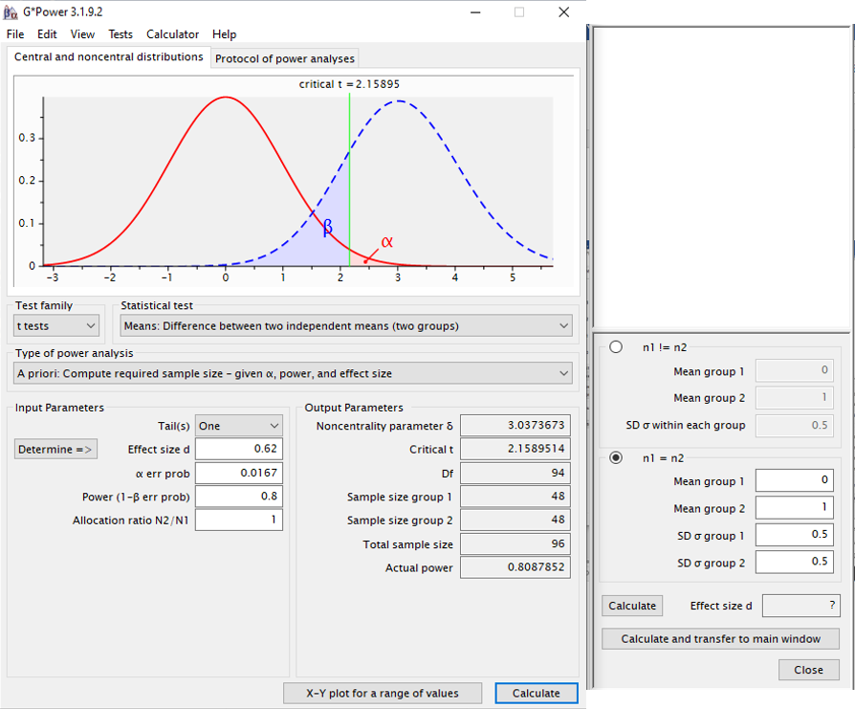

*Figure D8.* Medium effect (*gs* = 0.62), ANOVA with post hoc tests.

**Table 7**

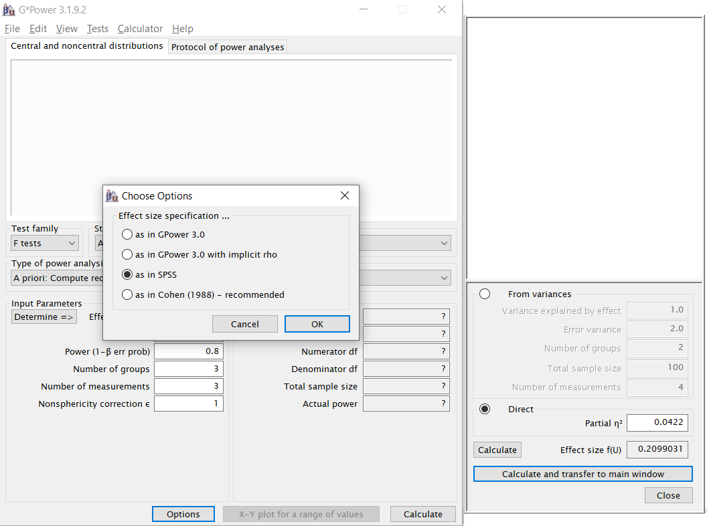*Figure D9.* G*Power’s “as in SPSS” option required for RM-ANOVA (omnibus only) power calculations.

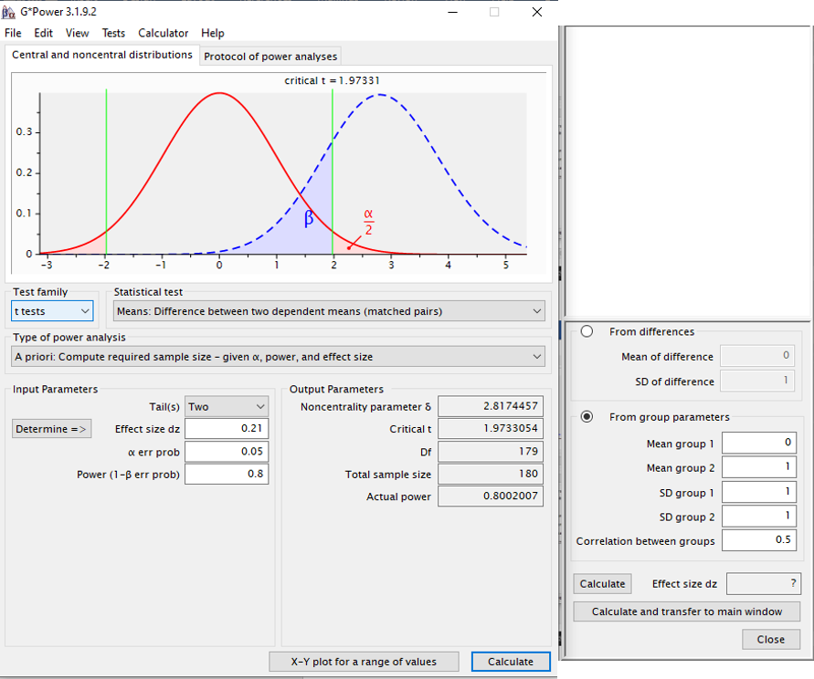

*Figure D10.* Small correlation (*r* = 0.31), ­*t*-test.

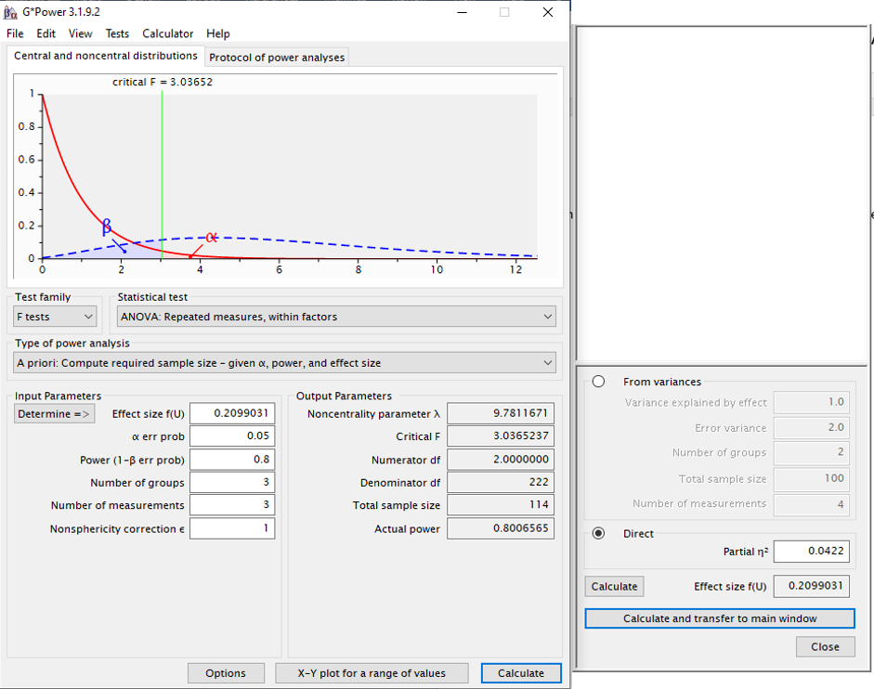

*Figure D11.* Small correlation (*r* = 0.31), RM-ANOVA omnibus only.  
  
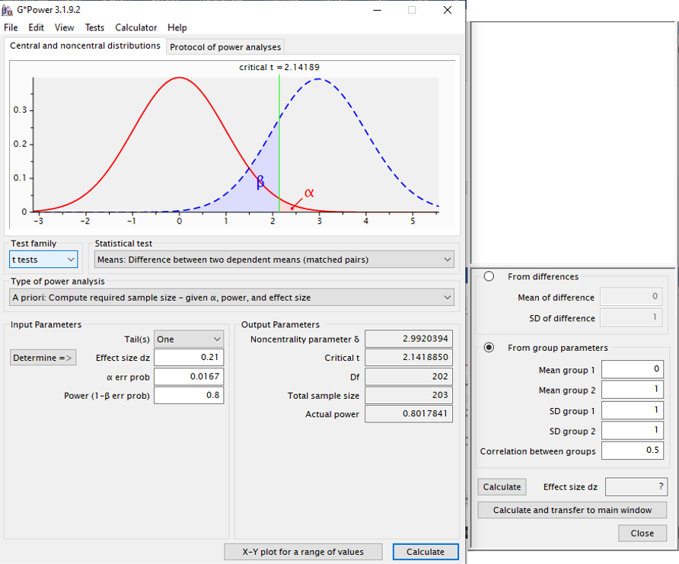

*Figure D12.* Small correlation (*r* = 0.31), RM-ANOVA with post hoc tests.

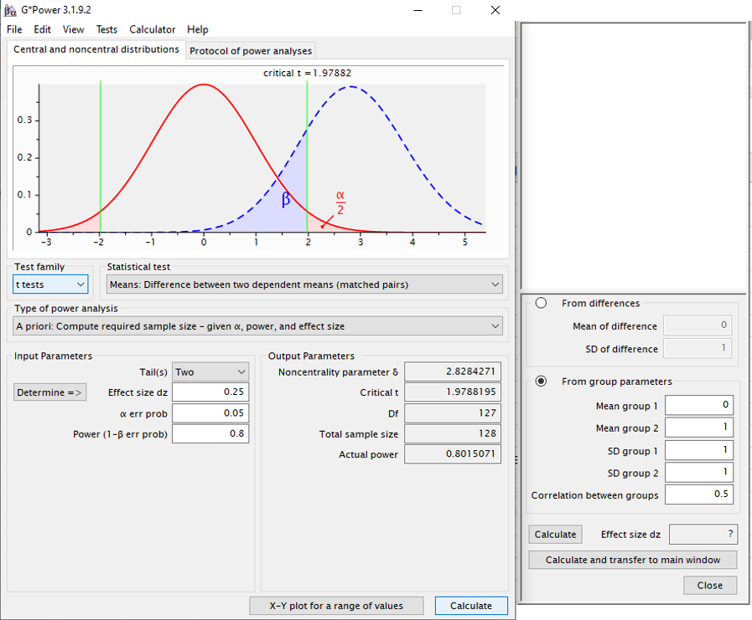

*Figure D13.* Medium correlation (*r* = 0.50), *t-*test.  
  
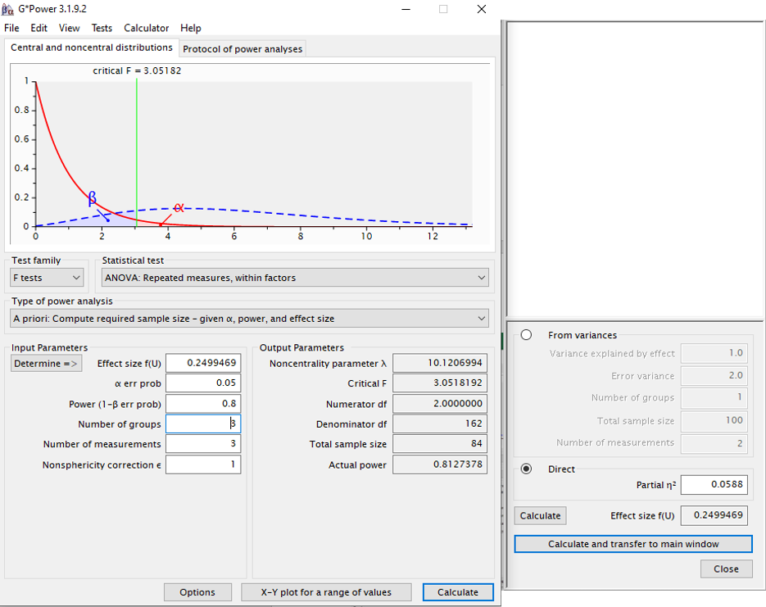  
*Figure D14.* Medium correlation (*r* = 0.50), RM-ANOVA omnibus only.

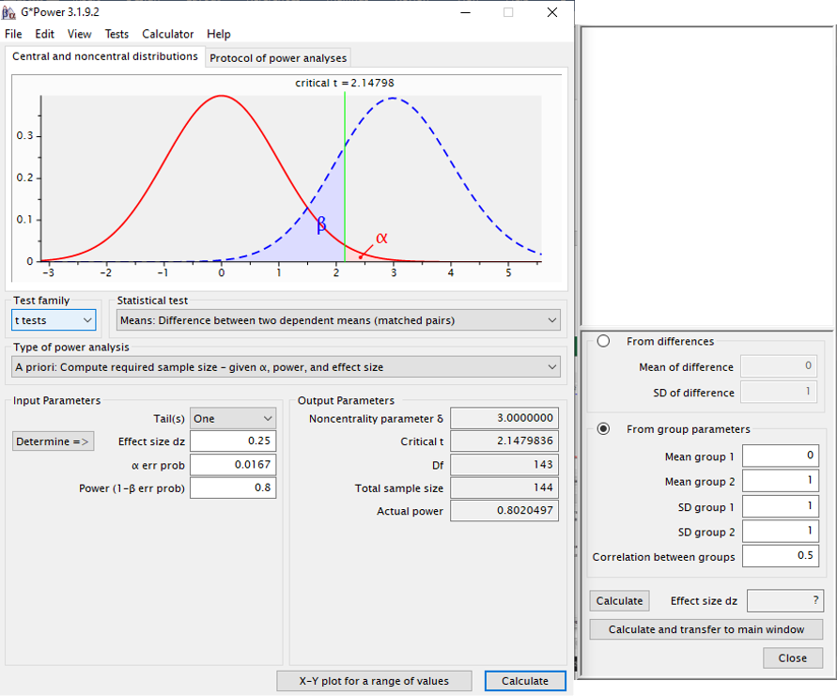

*Figure D15.* Medium correlation (*r* = 0.50), RM-ANOVA with post hoc tests.

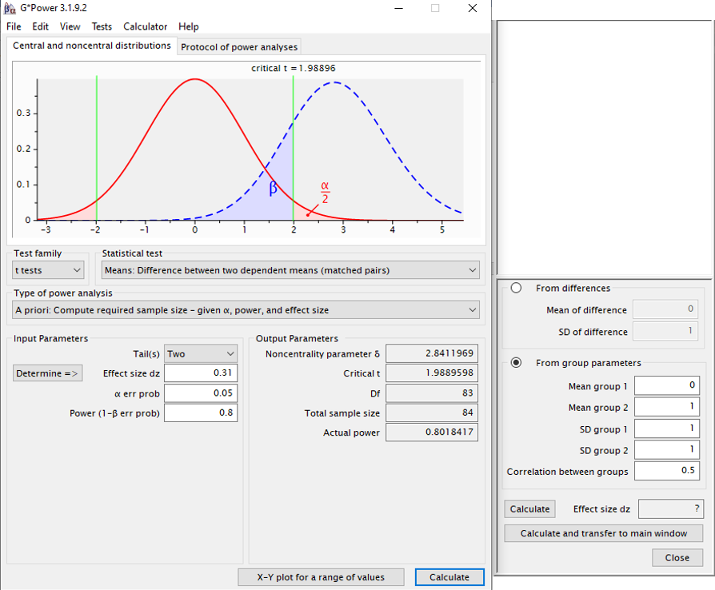

*Figure D16.* Large correlation (*r* = 0.68), *t-*test.

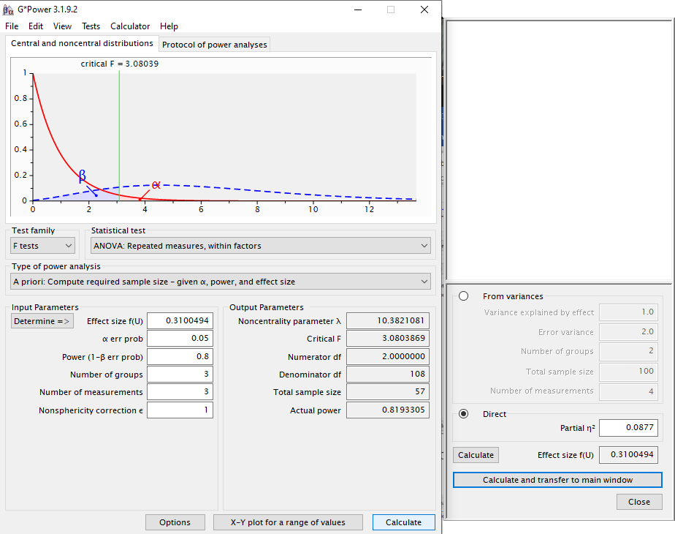

*Figure D17.* Large correlation (*r* = 0.68), RM-ANOVA omnibus only.

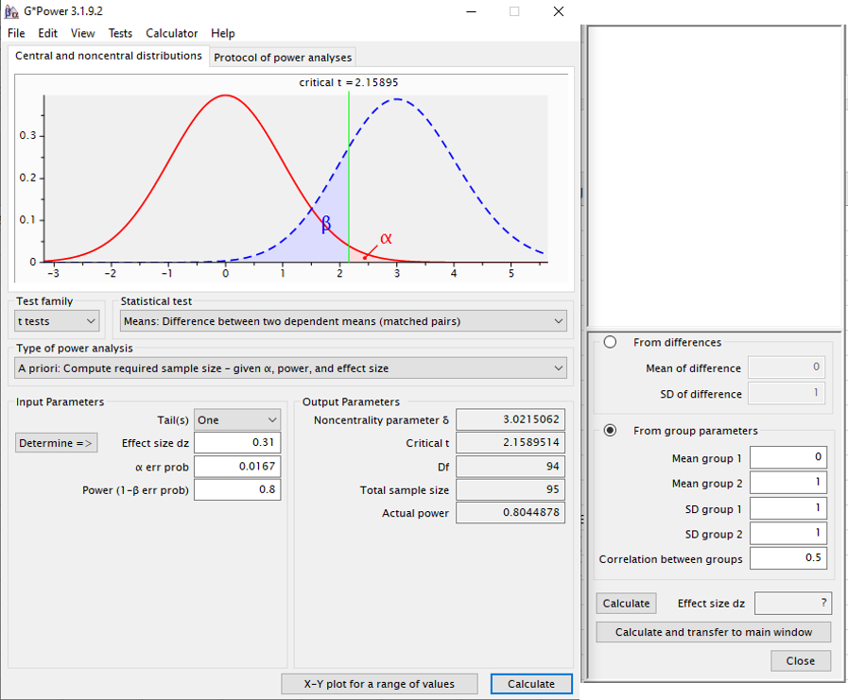

*Figure D18.* Large correlation (*r* = 0.68), RM-ANOVA with post hoc tests.